**COMSATS University, Islamabad**

Experiment # 2

Measurement of Variation in Photoelectric Current with the Change in Intensity of Light

Author: Muhammad Mujtaba

SP22-BSE-036

Course: Applied Physics for Engineers (PHY-121)

Instructor: Dr. Lubna Tabassum

Date: February 21, 2022

**Abstract**

In this experiment, we used a photocell and a light source to create a potential difference, which is directly proportional to frequency and intensity of the light source.

**Equipment**

Photocell fitted in a box having lamp, meter rod, micro ammeter, resistor (load), intensity meter with detector (solar cell) and 220 volts mains.

**Procedure**

1. Give a supply of 220 V to the lamp.
2. Switch on the lamp and move the lamp from extreme position towards photocell. There will be a deflection on micro ammeter at certain distance. Record this distance ‘d’ and reading of photocell current ‘I’ from micro ammeter. Then continue recording the readings of micro ammeter with distance reduced to an interval of 5 cm.
3. If the distance of lamp from the photocell is denoted by ‘d’ then the intensity of light L is proportional to 1/d2 i.e. L = constant/d2
4. Plot a graph between intensity L i.e. 1/d2 and current ‘I’ which will be a straight line, which indicates that intensity of light is proportional to photo current.

**Diagra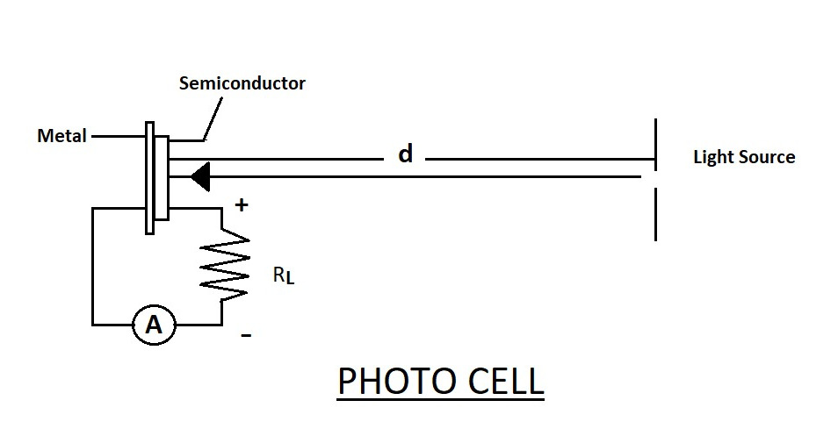m**

**Data & Calculations**

|  |  |  |
| --- | --- | --- |
| Distance (cm) | Current (uA) | Light Intensity (L) ( 1/d2) (cm-2) |
| 60 | 0 | 0.0002 |
| 55 | 0 | 0.0003 |
| 50 | 10 | 0.0004 |
| 45 | 20 | 0.00049 |
| 40 | 25 | 0.00062 |
| 35 | 38 | 0.00081 |
| 30 | 58 | 0.0011 |
| 25 | 98 | 0.0016 |

**Formula Used:** Light Intensity L α 1/d2

**Graph**

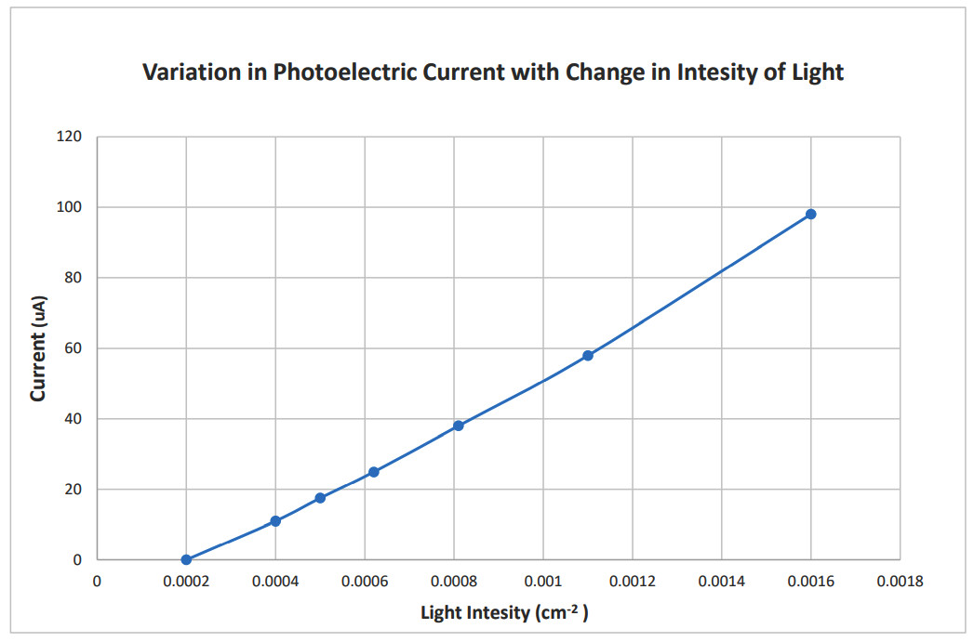

**Result**

Our experiment concludes that the photoelectric current I increases linearly with respect to the intensity of light L.

**Precautions**

1. Expose the photocell to light for short interval of time.
2. The lamp should be moved towards the cell along the straight line.
3. Take atleast 12 reading in each case.
4. The distance of electric lamp should be changed linearly, without changing the angle at which light falls initially.
5. Lamp should not be very close to the photocell to avoid overheating.